Why this feedback form?

* **Oblivion can be minimized by metacognition (=?)**
* **Adapt discussion / teaching to students**

**Graph of oblivion**

**(several repetitions)**

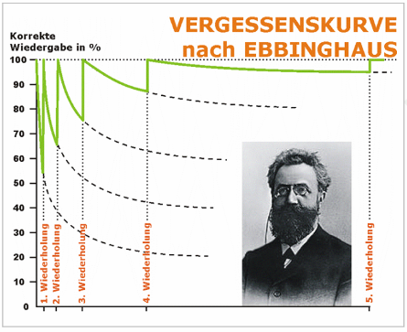

**Meta-Kognition / Concept Map**

**(reflect about successful learning, visualize knowledge)**

(≠ mind map)

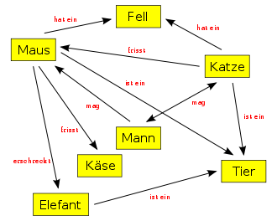

Questions:

* Keep up attention AND teaching content?
* Strukturierung von Unterrichtsmaterial auf Uni-Ebene
* Integration von Stud. (Frontalunterricht – interaktiver Unterricht)
* Overview of alternative (ZEM)
* Account of teaching experiences (Praxiserfahrungen)
* Educanet

Time schedule = OK.